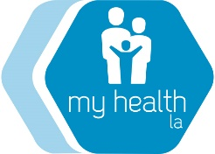
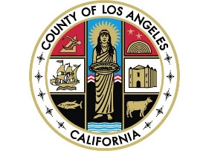

<Day>, <Date>

Dear My Health LA Participant,

Greetings from the My Health LA (MHLA) Program! We hope you are doing well.

We also are excited to announce that in January 2024, you will be eligible to apply for Full-Scope Medi-Cal regardless of immigration status.

Please ask your clinic for help signing up for Restricted Medi-Cal (also called Emergency Medi-Cal) as soon as possible. Then, on January 1, 2024, you will be moved into Full-Scope Medi-Cal, which has more benefits than MHLA. Please look at the included flyer for details on those benefits, like vision and long-term care.

The My Health LA Program is ending on January 31, 2024. To continue getting your healthcare from your Medical Home Clinic, you should apply for Restricted Medi-Cal as soon as possible.

If you have any questions about your immigration status, please call the numbers on the attached flyer. You can also contact your Medical Home Clinic, <Medical Home Clinic>, at <Clinic Phone Number>. You can always reach MHLA Member Services at (844) 744-6452

Thank you and remember, please sign-up for Restricted Medi-Cal now.

Sincerely,
The My Health LA Program

